
Ability is Not Fixed

Dreams Don’t
Work Unless You Do

A Flying Start

Parents’ Guide 2025/26

The Transition Team

Mrs Hibbins– Assistant Principal and Transition Leader

Mrs Hibbins is part of the leadership team at the College and leads the transition process.

Mrs Mindham – Assistant Principal and Special Educational Needs Co Ordinator

Mrs Mindham is part of the leadership team with responsibility for the enhanced transition of any students who may require additional support. She is also our SENCO (Special Educational Needs Co Ordinator).

Mrs Cook – Transition Officer

Mrs Cook is responsible for the admission of all new students and liaises with parents to support the admissions process.

Pastoral System

Your child will be in Year 7, and they will have their own tutor group. They will spend 25 minutes each morning with their tutor and have a weekly assembly led by their Head of Year. On Friday morning they will have a Friday Debate on current affairs.

Your child will also be placed in one of four houses, Aspire, Endeavour, Perseverance and Fortitude. Many competitions, rewards and activities are organised around these houses.
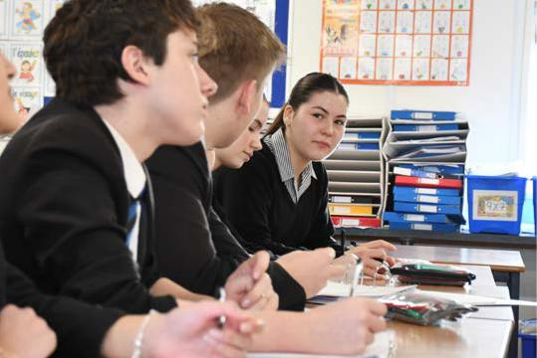

What is different about life in Secondary School?

Please talk to your child about these differences to help them get off to a flying start.

Ten Teachers

Your child will have at least ten teachers as well as their tutor, a Head of Year and maybe some teaching assistants. Most of their teachers will see them once or twice a week in a class of 20-30.

Bear in mind the average secondary teacher will teach 200+ students a week. Explain to your child that although they may not know every teacher quite as well as they do their current Year 6 teacher, this approach means they will benefit from being taught by experts in their field.

All teachers follow the same basic procedures, but there are bound to be natural variations in approach.

Talk to your child about how they can establish a good relationship with all their teachers.

Six Lessons

There are six lessons a day, in up to six
separate locations, which means a lot
of movement and more to carry around.
With 900 students in school some corridors get busy at times though we
play music to indicate the movement time

allowed between lessons. When the music
stops, students have 1 minute to get to their
classroom. We make allowances in the first
few weeks and there are lots of people
around to help.

Your child will soon adjust,
but if you talk the process through with them it helps them to prepare.

Ready to Learn

Help your child to be organised for secondary school. They will have a timetable and should check it carefully every morning, but they will also have a copy of it on their EduLink App. The App also tells them when their homework is due but they should avoid leaving it to the last minute because unexpected events do happen. If your child has a learning difficulty, we provide additional help and guidance with homework. You can find their homework deadlines on your EduLink App.

Talk to your child about being organised with their homework so they are fully prepared.

Youngest Again

At primary school they were the oldest pupils but now they will be the youngest, and in a larger school. However, you can reassure your child that most of their time is spent in classes with young people of their own age.

Friendships

Well-established friendships often change when leaving primary school and new friendship groups may form. At primary school, most children know their class very well but in secondary there may be people in their classes they do not know. Your child will want to fit in and may become a little more self-conscious as a result. This is perfectly normal but talking to your child about their experiences helps them not to become too anxious about them.

Travelling

Most of our students travel to school by bus and this may cause some anxiety initially. We do not hire the buses ourselves and neither do we police them, but we have a bus code and monitor it carefully. If your child is very anxious about travelling on the bus, or even waiting at the bus stop, you might suggest they put in headphones as a distraction.

Your child may also worry about missing their bus. This is rare but if it happens, they must tell reception or a teacher immediately. We will ensure your child gets home safely in any event.

Differences for Parents

If you have not had a child go to secondary school before it can be difficult for parents to adjust at first. It may be helpful to remember the following:

Who to Contact

There are more staff working in a secondary school. Casterton employs 130 people, and your child may interact with 20-30 of them during any given week, sometimes more. Therefore, parents may struggle to know who to contact. This is why we ask parents to contact the school via enquiries@castertoncollege.com or by ringing reception. Then we can direct

you to the best person to deal with your enquiry.

Engaging with school

There is no gathering of parents at the school gate at secondary school so they cannot just ‘pop-in’ when they want a word with a teacher. Also, parents who had made friends with each other may miss those connections and feel less connected with school in general.

However, there are still plenty of ways to engage with school. You can use the EduLink App, attend parent's evenings and other events, and remember you get three reports on your child’s progress every year. You can also read fortnightly updates from the principal, get regular 15-second surveys to complete as well as social media posts on Facebook and Instagram and our end of term newsletters. We will message you with various reminders and updates and of course, ring you if there is something particularly important.

Puberty


Puberty usually happens at some point between years 6-9 and this can be challenging for parents. Their previously carefree child might become anxious, distant, moody, or even difficult at times.

Also, remember your child may act differently with you at home, to when they are with their peers at school, particularly as they become teenagers. You still know your own child better than anyone else, but teenagers also want to establish an identity outside of the family, and this may present itself in different ways in school. The key is to work with us on how best to navigate your way through this potentially tricky period in their lives.

Family Strains

Parents’ own lives also change as their children get older. Separated families may become more complex and teenagers may be less accepting of new arrangements. Parents may experience health difficulties of their own or become carers for other family members. These and other problems can create strains, feelings of guilt, anxieties and frustrations which are difficult to manage, particularly when you have a challenging teenager to cope with. Be fair on yourself, no parent is perfect but recognise that your child still needs you. The good news is, young people are resilient and capable of understanding a great deal, particularly now they are older themselves.

We want to work in partnership with you because it is important all the adults your child's life work together and not against one another. Support your child by supporting us.

Getting into good habits

- Encourage your child to pack their bag and check their timetable daily.

- Your child’s timetable is on their EduLink App, but they also get a paper copy and should do their best not to lose it. Get them into the habit of thinking “bag, bus pass, keys, PE kit and basic equipment” before leaving the house each day.

- Their tutor will check they have the right equipment every morning and if anything is missing, your child will be sent to our stationery shop where they will be provided with the missing items. Maths teachers will check your child has their maths equipment in every lesson, such as calculators and other specialist items.

- We serve breakfast in school from 8am every morning. Packed lunches are welcome but ideally, we’d like your child should have a warm, healthy meal at lunchtime. Check your child’s account is topped up but we would never let them go hungry.

- Check your child’s uniform is correct before they leave the house, including wearing a tie, proper school shoes, and black socks. Check the rules on jewellery and piercings to avoid unnecessary conflict as we check these carefully before and after every lesson. Explain to your child that we have a uniform so that young people don’t compete on who is wearing the most expensive or most fashionable clothes because that is unfair and causes unhappiness. Most young people accept this is fair.

Transition Week

Your child will spend a whole transition week with us from 30th June to 4th July. It is unusual for a secondary school to spend a whole week on transition, normally it is just a day or two, but we think it is important. The week is organised to be fun and to reassure young people about coming to us.

However, you will need to transport your child to and from Casterton for this week.

Home School Communications

When your child joins secondary school, you can keep an almost continuous link to what is happening in school including attendance records, prep (homework) deadlines, menus, trips and visits, timetables and a lot more besides via our EduLink App.

EduLink

EduLink can be accessed by parents and students via an app or on a PC or laptop. Parents will be sent an invitation to register for EduLink in the first week of term. Students will be shown how to access EduLink at school and use their school email details (Microsoft Office 365) to access EduLink.

EduLink is used to show lots of helpful information including timetables, prep (homework), extra-curricular activities, achievement and behaviour. We also share key documents such as school reports and newsletters via the EduLink app (school reports are also emailed home). As your child moves through their secondary education, we also use EduLink to share exam information.


Parents’ Evenings

Progress reports and parents’ evenings are a good chance for you to get to know your child’s teachers. We will also make you aware of their Attitude to Learning and give you information that will help you to keep track of the progress your child is making.

In year 7 you will have two face-to-face Parents’ Evenings. The first will be in the Autumn term with your child’s tutor and the second later in the school year with their subject teachers. You will also receive three progress reports.

Prep (Homework)

We take great care to phase prep in slowly and ensure the tasks are appropriate and useful. You can see what prep your child has and when it is due on the EduLink App.

You can help your child by talking with them about their prep.
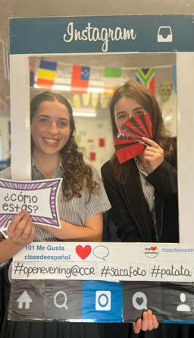

Attendance
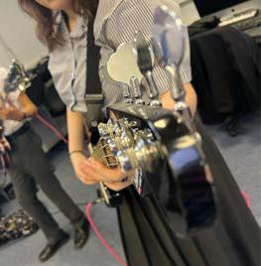

Attending school is vital for your child’s education and well-being. Missing lessons causes them major problems. Apart from serious illness, there is no reason why the attendance of a normal, healthy child should fall below 95%.

Missing school is bad for a young person’s mental health and may make them anxious and socially isolated. Sometimes, mental health is cited as a reason for not attending school, but continued absence feeds the problem and makes it much worse.

There is a close correlation between poor attendance and problems later in life, probably because being well-educated brings with it so many other benefits.

To report an absence, you use a different App called Studybugs

If you child is poorly and unable to attend, please contact us via the Studybugs App which we will send you or inform our Attendance Officer on 01780 762168 option 1. Give your child’s name and symptoms, before the start of the school day.

Please try to book medical appointments outside the school day, if this is not possible, please provide the Attendance Officer with an appointment card, before the day of the appointment.

Basic Equipment

Your child will need the following every day

2 Black pens

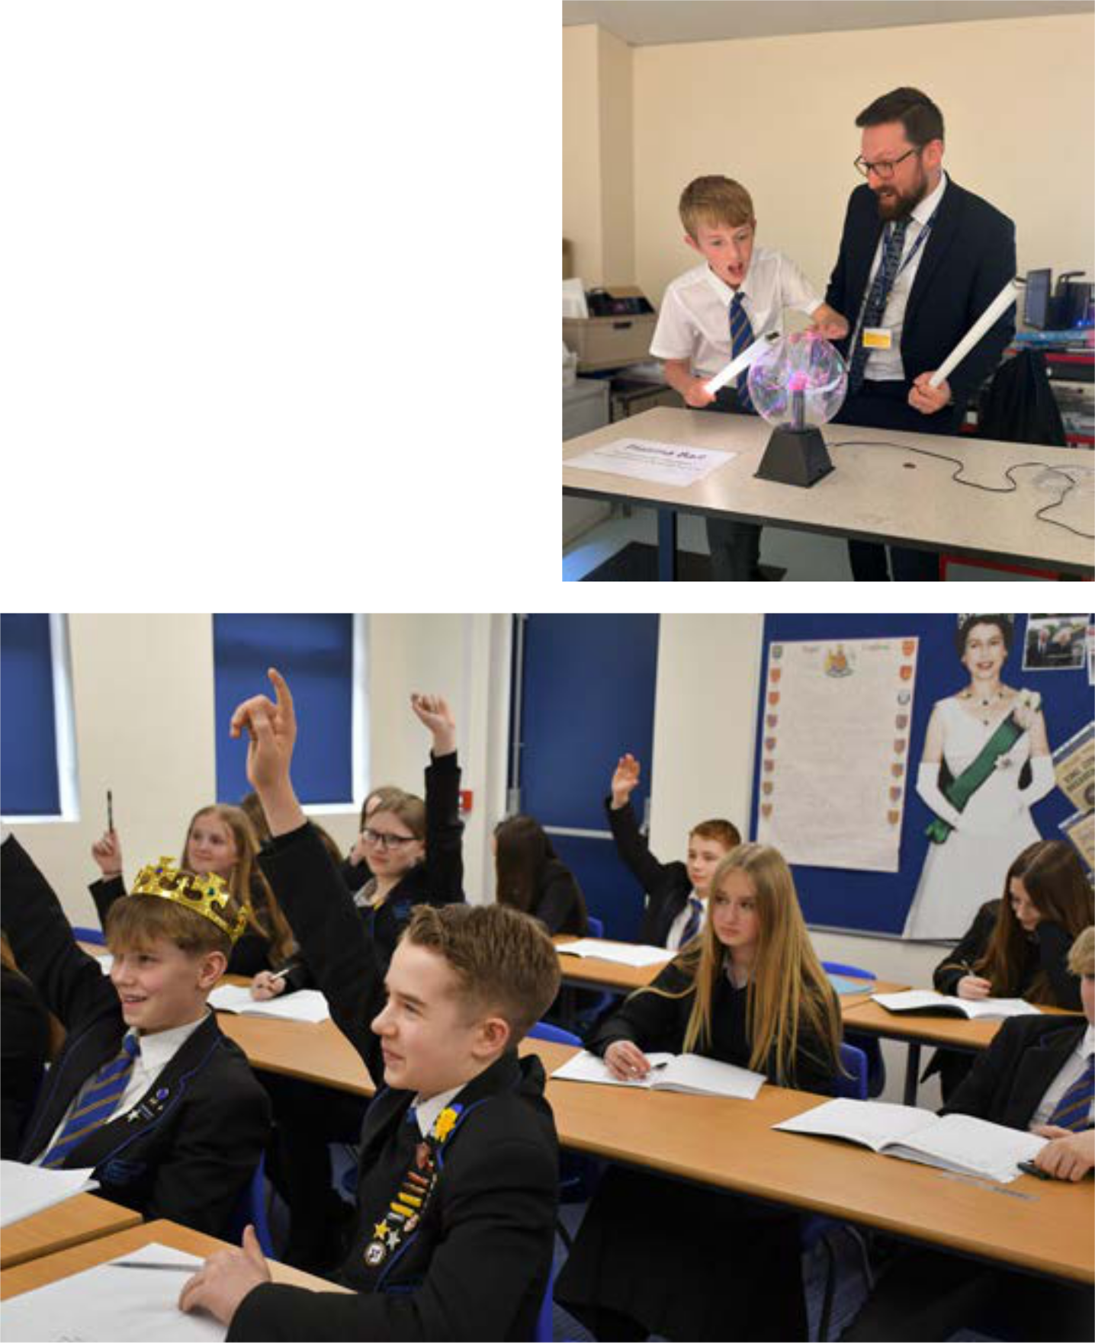
2 Pencils

2 Green pens

30cm Ruler

An Eraser

Pencil sharpener

1 Protractor

Pair of compasses

Scientific calculator (AURORA AX-59 5TV or CASIO FX-83GT CW)

Behaviour

We have high behaviour expectations because every student has the right to learn and feel safe. We help young people with emotional and mental health difficulties to manage their own behaviour, but poor behaviour will never be excused.

Ready to Learn

Ready to Learn (RTL) is our behaviour policy and it has been highly successful for many years.

Students are expected to follow 3 simple rules:

- Listen to and respect the teacher.

- Not disrupt others.

- Stay on task.

Students are expected to:

- have the correct equipment

- arrive on time to lessons

- wear their uniform correctly

- keep mobile phones out of sight

Rewards

There are lots of rewards to earn at Casterton and at the end of every term we have a success assembly, handing out prizes and certificates to lots of students. There are many ways to earn rewards, but they are mostly for going over and beyond what is normally expected.

You will be able to check your child’s achievement points on your EduLink App.

SEND (Special Educational Needs and Disabilities)

We want every young person with Special Educational Need and/or Disabilities (SEND), to fulfil their potential. Having SEND has nothing to do with ability, it may be a

barrier to learning and require the right support but people with SEND are as clever as anyone else and we do not limit our expectations because they have SEND.
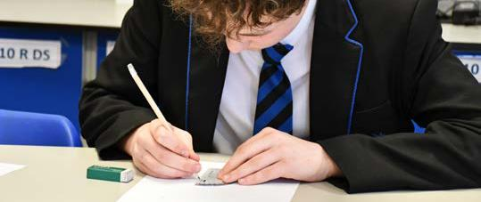

Most young people with SEND are admitted in the same way as everyone else but some parents, particularly those with children on an Education, Health, and Care Plan (EHCP) may wish a prior meeting with our SENCO (Miss Mindham). We work closely with primary schools to get the best information on each child with SEND in advance so we can provide the right support. Some students with SEND have visits prior to transition week in July. Please contact us at enquiries@castertoncollege. com with any questions for Miss Mindham.

All our students are tested on arrival to help us get a precise understanding of their needs and all their teachers are given two strategies for every child with SEND they teach, known as the Required Common Practice (RCP).

A large team of teaching assistants (TA’s) support our students with SEND and many of them also have a link TA who acts as the main point of contact between yourself and school on SEND matters. Some TAs are specialists leading specific programmes to support children with certain types of SEND, often in small groups, while others may provide more general classroom support.

We also have termly coffee mornings for parents of young people with SEND because communication and partnership is the key to success.

Reading

Reading is very important to us at Casterton, and we pride ourselves on ensuring no young person leaves without becoming a fluent and confident reader.

We say the readers of today are the leaders of tomorrow. However, while the secondary curriculum was originally set up on the assumption that all young people could read fluently by the age of 11, we know the reality is different, so we’ve made it our mission to change that.

We also know that reading is a habit, and even confident, enthusiastic readers benefit from a structured programme of reading.

At Casterton, your child will read in silence for at least 20 minutes every day and a further 15 minutes at the start of English lessons. We also ask that they read a further 20 minutes at home each day.

To do this we use a programme called Accelerated Reader (AR)

AR is an internationally recognised programme for which we have been awarded Champion School status for best practice.

Accelerated Reader is used to:

- Determine your child’s reading ability, guide students to books that are challenging enough to ensure they make good progress but not so challenging they cannot access it or become frustrated or disheartened.

- Monitor your child’s reading progress over time and set termly targets based on their progress.

- Provide a database of over 30,000 quizzes to monitor your child’s comprehension of the books they have read.

- Give instant feedback to your child.

- Allow parents to view their child's progress and receive email updates via the parent site: Home Connect.

- Provide various reports to enable
effective monitoring by teachers.

- Build confidence by ensuring your child understands what they are reading and, therefore, enjoys their reading experience.

- Encourage students to read a wide variety of books.
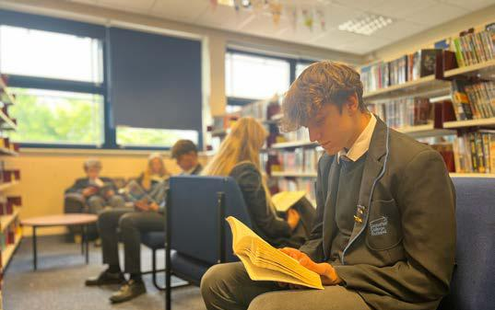

Uniform
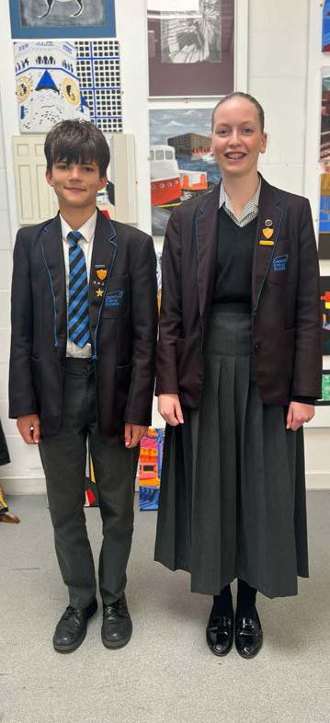

All our students wear their uniform with pride. The uniform is available to purchase from: - Shotbowl Ltd

2, Blenheim Way Northfields Ind. Estate Market Deeping Peterborough PE6 8LD

Tel: 01778 348788
Enquiries: shop@shotbowl. com

Visit: www.shotbowl.com, click on school uniform and a box for Casterton College Rutland will appear.

Shop Opening Hours

Mondays Closed Tuesdays 10am – 5pm Wednesday 10am – 5pm

Thursday 10am – 5pm Friday 10am – 5pm Saturday 10am – 4pm Sunday Closed

We also have a Facebook page for second hand uniform which you can access at CCR uniform selling group.

Transport

Most students travel to and from school by bus and these are direct to our campus.

For more details on the College bus services or to apply for a bus pass, please go to School transport | Rutland County Council or telephone Rutland School Transport Department on 01572 772392.

There is also a bus from Stamford, (paid on Mondays).

Some students choose to walk or cycle to and from school, but we will need to know if this is the case.

Cyclists must never directly leave the site on their bikes, as the exit to Ryhall Road is blind and can be dangerous. There are many buses, and the traffic is heavy at that time.

Instead, we ask cyclists to walk their bike down the Ryhall Road to the zebra crossing before mounting at the end of the day.

A cycle path begins on Casterton Road, near to the petrol station, and continues to Ryhall Road.

A cycle shelter at the front of school provides a dry place for cycles to be stored during the day. Cyclists are guaranteed a locker to store their cycle gear.

E-Scooters are not allowed.

Students must wear a correctly fitted cycle helmet and use appropriate reflective clothing and bike lights.

Safe checks and guidance can be found at www.sustrans.org.uk.

If travelling by car is the only option, please ensure you park considerately in the nearby roads or in the nursery car park. Do not come into the main car park as there are too many students walking around for it to be safe. Drop off and collection times can at times be difficult, so why not speak to the parents of your child’s friends about car sharing.

Food

The school dining room is called “The Courtyard.” A cashless system operates which means that your child uses their fingerprint to “pay” for their food.

If students have any special dietary requirements, we will accommodate them wherever possible. Please do not hesitate to let us know if your child has any special dietary requirements.

Chilled water is available at several points throughout the College. We ask you to support our healthy eating code by not letting students bring fizzy drinks, sweets, or chocolate into school.

Students are asked not to eat food outside the courtyard.


ParentMail

ParentMail allows parents to pay for lunches, trips and revisions guides etc. Logins and password will be issued once your child is on roll. There is also link to ParentMail on the College website.

You can add money to your child’s account via ParentMail anytime. We ask that you ensure your child has enough money on their account each day.

For more information visit our website or www.parentmail.com or contact the College’s Finance Office 01780 762168 Option 3.

If you think your child is eligible for free school meals, you can check your eligibility online by visiting our website www. castertoncollege.com and selecting the link for Free School Meals.
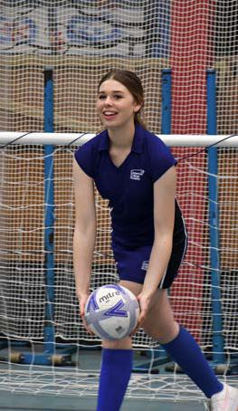

Your child may be able to get free school meals if you get any of the following:

- Income Support

- income-based Jobseeker’s Allowance

- income-related Employment and Support Allowance

- support under Part VI of the Immigration and Asylum Act 1999

- the guaranteed element of Pension Credit

- Child Tax Credit (provided you are not also entitled to Working Tax Credit and have an annual gross income of no more than £16,190)

- Working Tax Credit run-on - paid for

4 weeks after you stop qualifying for Working Tax Credit

- Universal Credit - if you apply on or after 1 April 2018 your household income must be less than £7,400 a year (after tax and not including any benefits you get)

Children who get paid these benefits directly, instead of through a parent or carer, can also get free school meals. These details are for advice only, please check the latest government guidelines for more information.
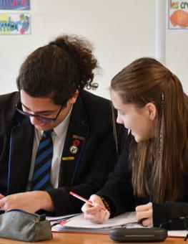

Medical

If your child feels unwell during the day, they should report to the medical room in student services. If necessary, we will telephone you for you to collect your child.

We have several trained first aiders in school and in the event of an accident or emergency they will assess the situation and act accordingly. However, they are not trained nurses or medical practitioners will seek appropriate medical advice where necessary.

Students are not permitted to call a parent independently and request to be picked up due to illness. If your child does this ask to speak to a member of staff immediately.

We will gather information on specific medical conditions your child may have later, at which point you may wish to discuss these in more detail with our medical officer.

Mobile Phones
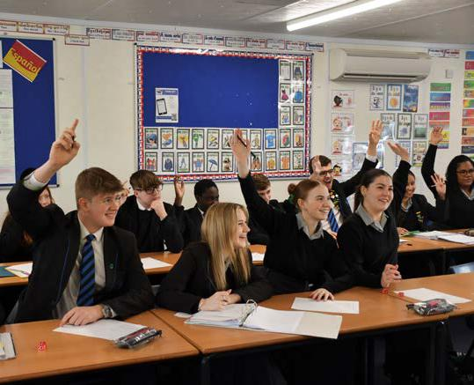

If a student is seen with a phone, it will be confiscated. This includes in the morning before the first bell goes, and in all indoor and outdoor locations. Phones must not be seen sticking out of pockets or bags.

Parents are advised to visit our website and look at the parental guidance for more information. There are some particularly useful links regarding use of social media sites and avenues for reporting concerns online.

In an emergency, parents should ring our main reception. Students are not allowed to ring their parents during the day unless we have directed them to do so for a specific purpose.

Casterton College Rutland Ryhall Road, Great Casterton, Rutland, PE9 4AT

01780 762168
www.castertoncollege.com
enquiries@castertoncollege.com

