Dishes | 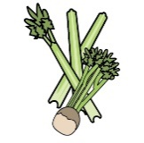 | 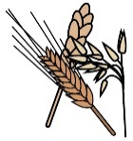 | 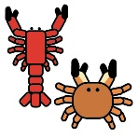 | 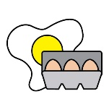 | 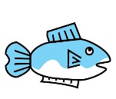 | 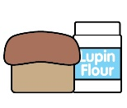 | 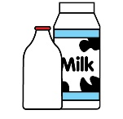 |  | 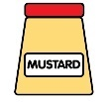 | 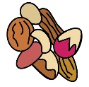 | 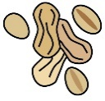 | 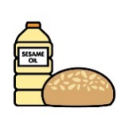 | 
 | Celery | Cereals containing gluten* | Crustaceans | Eggs | Fish | Lupin | Milk | Mollusc | Mustard | Nuts† | Peanuts | Sesame seeds | Soya
Beverages
Bottled water
Flavoured waters
Fruit juices
Milkshake |  |  |  |  |  |  | YES
Fruit smoothies
Pastries
Double chocolate cookie |  | WHEAT |  | YES |  |  |  |  | YES
Blueberry muffin |  | WHEAT |  | YES |  |  |  |  | YES
Gingerbread |  | WHEAT |  |  |  |  |  |  | YES
Oh so scrummy blackjack |  | OATS
Mini cookie bag |  | WHEAT |  |  |  |  |  |  | YES
Pan au Chocolat |  | WHEAT |  |  |  |  |  |  | YES
Belgium waffle |  | WHEAT |  | YES |  |  |  |  | YES
Jam doughnut |  | WHEAT |  | YES
Hot Snacks
Vegan sausage roll | YES | WHEAT |  |  |  |  |  |  | YES |  |  |  | YES
Cheeseburger | YES | WHEAT |  |  |  |  | YES |  | YES |  |  | YES
Mozzarella sticks |  | WHEAT |  | YES |  |  | YES
Halloumi Brioche |  | WHEAT |  | YES |  |  | YES |  |  |  |  |  | YES
Steak slice |  | WHEAT |  | YES |  |  | YES |  | YES
Vegetable samosa | YES | WHEAT |  |  |  |  |  |  | YES
Chicken skewer
Big ALS pizza twist |  | WHEAT |  |  |  |  |  |  | YES |  |  |  | YES
Dessert
Fruit Bag
Apple
Banana
Fruit Yogurt |  |  |  |  |  |  | YES
Popcorn Sweet and Salty
Salted Proper Chips
Hot dishes
Spaghetti bolognese with garlic slice | YES | WHEAT |  |  |  |  | YES |  | YES |  |  |  | YES
Cheese toastie |  | WHEAT |  |  |  |  | YES
Chicken korma rice and naan bread | YES | WHEAT |  |  |  |  | YES |  | YES | (COCONUT) |  |  | YES
Pomadora Penne pasta |  | WHEAT
Bangers and mash with gravy | YES | WHEAT |  |  |  |  | YES |  | YES |  |  |  | YES
Basilico pasta |  | WHEAT
Spaghetti carbonara with garlic slice |  | WHEAT |  | YES |  |  | YES
Sweet potato ribbles
Cream of tomato soup |  | WHEAT |  |  |  |  | YES |  | YES
Jacket potato with a butter |  |  |  |  |  |  | YES
Jacket potato with baked beans
Jacket potato with cheddar cheese |  |  |  |  |  |  | YES
Jacket potato with coleslaw |  |  |  | YES |  |  |  |  | YES
Tuna Mayo Roll |  | YES |  | YES | YES |  | YES |  | YES
Egg Mayo Roll |  | YES |  | YES |  |  | YES |  | YES
Houmous |  |  |  |  |  |  |  |  |  |  | YES
Tortilla Chips
Breadsticks |  | YES
Tomato Dip Pot | YES
Mayonnaise Dip Pot |  |  |  | YES |  |  |  |  | YES
Barbecue Dip Pot
Cheese Roll |  | YES |  |  |  |  | YES
Double Bacon Bap |  | WHEAT |  |  |  |  |  |  |  |  |  |  | SULPHITES
Hot Dog | YES | WHEAT |  |  |  |  |  |  | YES |  |  |  | SULPHITES
Hash Browns
Chicken Caesar Salad |  | BARLEY,  WHEAT |  | YES |  |  | YES |  |  |  |  | SOY/SOYA | SULPHITES
Greek Cheese Caesar Salad |  | YES |  | YES |  |  | YES |  |  |  |  | SOY/SOYA | SULPHITES
Cheese Coleslaw Salad |  |  |  | YES |  |  | YES |  | YES
Tomato Pasta Salad |  | YES
Ham Roll |  | YES
Cheese Roll |  | YES |  |  |  |  | YES
Dishes and their allergen content Casterton College Rutland Term 1 2020-2021 Fusion Orders Break and Lunch

Review 21/08/2020 |  | Reviewed by: | A M Ash |  | 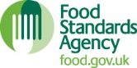 |  | You can find this template, including more information at www.food.gov.uk/allergy-guidance

